Calculation Example
Find the true length of the rafter.
The timber framing code AS 1684.2 – 1999 clearly differentiate between spacing and span (see Fig. 2.18 and Paragraph 2.7.5.
Spacing the centre-to-centre distance apart from structural members, unless otherwise indicated.

Span the face-to-face distance between points capable of giving full support to structural members or assemblies. In particular, rafter spans are measured as the distance between points of support along the length of the rafter and not as the horizontal projection of this distance.
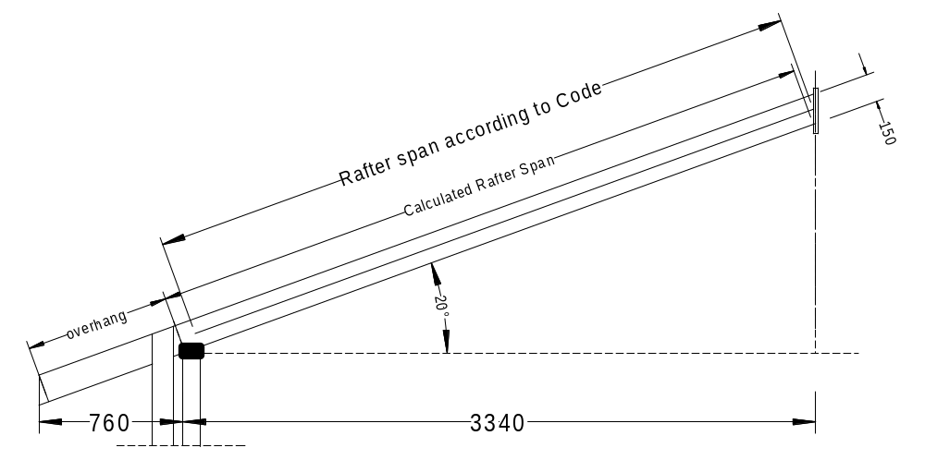
Figure 1
As can be seen the span of the rafter in the figure below is not quite in agreement with the code but we will use the figures for the rafter span as calculated below.

The angle  will be the roof pitch
The opposite site is the rise of the roof
The adjacent side is the rafter run
The hypotenuse is the true length of the rafter

In our example the roof pitch is 20°, and the rafter run is 3.340 metres.
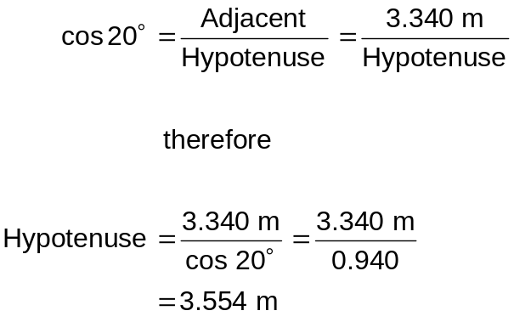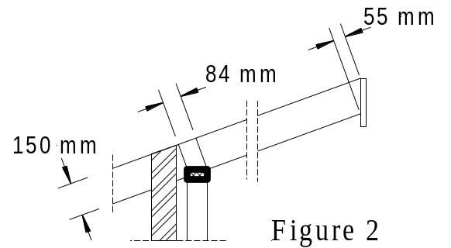

Therefore the true length of the rafter is 3.554 metre.

Please remember that the rafter span according to the Code is the face-to-face distance (measured along the centre line of the member) and that our calculated distance is 131 mm (84+55/2) longer in this case. This may be used in a border case where the next size would be required. In this case the size of a member may not need to be increased.
Now we have to find the eaves overhang. Look also at Figure 2.18 (b) in Section 2 regarding the length of the overhang.

Calculation of roof overhang fo a brick veneer construction

Let's assume an eave width of 600 mm. The horizontal dimension for the overhang is then 600 mm plus the 110 mm brickwall plus the 50 mm cavity, which equals 760 mm.
No we do the same as for the rafter (the overhang is in this case the Hypotenuse).
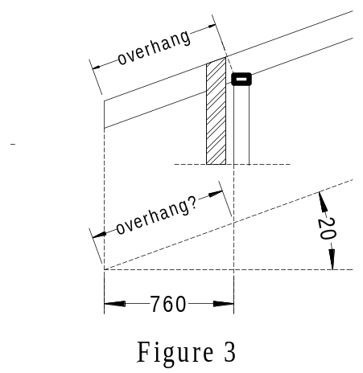
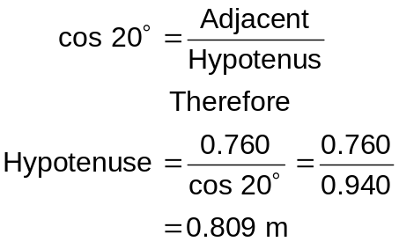
The eaves overhang for our brick veneer building with 600 mm eaves width is 0.809 metre

Find the length of a strut
If a rafter is supported on to points only (single span) and an appropriate size can not be found in the tables then an additional support (underpurlin) is needed. Underpurlins must be supported by struts.

Struts may be arranged vertically as shown in Figure 4 (a) or perpendicular to the rafter (b).
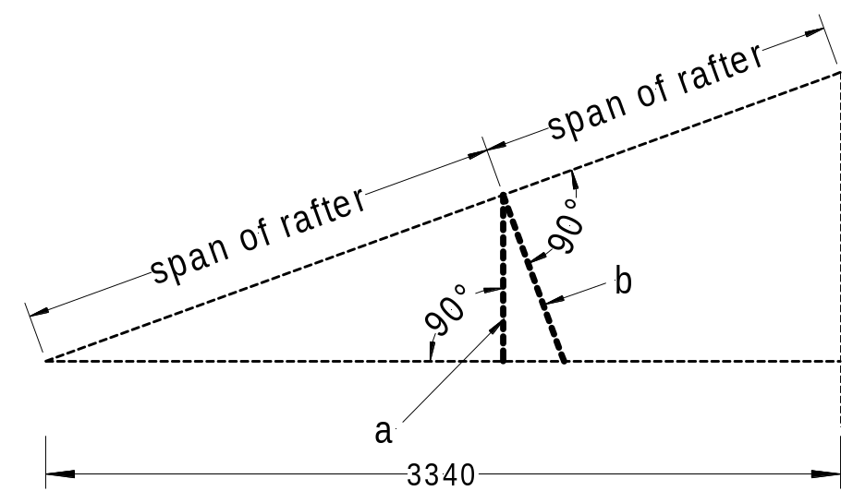
Figure 4

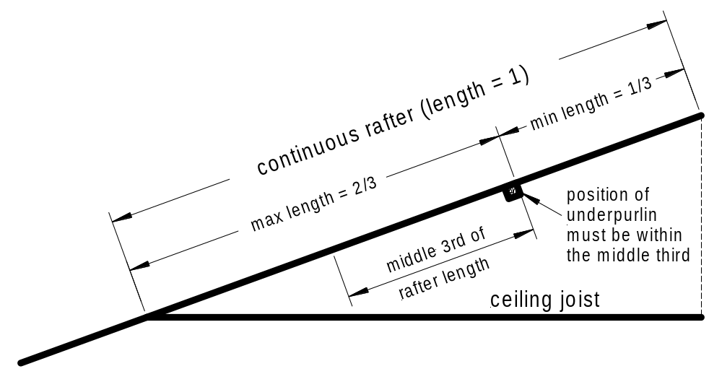The position of the underpurlin must be determined before we can calculate the length of the strut. To utilise the continuous span of a rafter the position of the underpulin must be in the middle one-third of the rafter as shown in the figure 5 Remember that continuous span member is a member whereby no span is greater than twice another (Section 2, Rule 2.7.5.5).
Figure 5

Consider Figure 4 above. As soon as we have determined the position of the underpurlin we can calculate the length of the vertical strut using sin or cos.

Vertical strut

If we position the underpurlin as shown on Figure 5 then the strut for the greatest rafter span possible is at position ⅔ of 3.554 = 2.369 metre. To calculate the vertical strut we use the tan-function. The adjacent site is 2.369 and the pitch is 20°.

Again the tan of an angle is
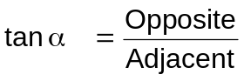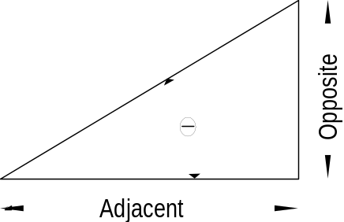
Therefore the length of the vertical strut is

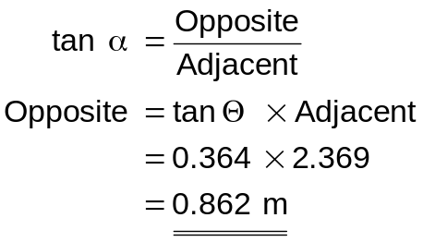

Perpendicular strut

To calculate the length of a perpendicular strut we need to calculate the rafter span (Hypotenuse) first. The rafter span is  of the run divided by cos 20°

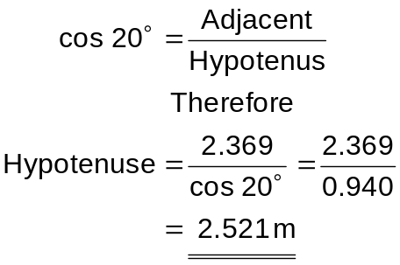

Now we can use the tan function again to calculate the strut perpendicular to the rafter.

The length of the perpendicular strut is therefore

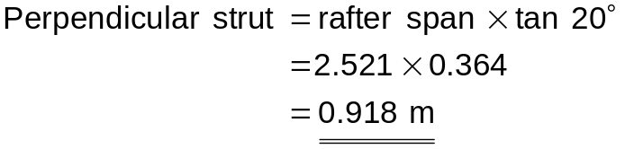

Fan strut

The span of an underurlin can be reduced if a fan-strut is used instead of a single strut. Paragraph 7.2.15.3 in As 1684.2 - 1999 stipulates that the angle of a fan-strut should not exceed 45°. (A single strut should not exceed 30° from the vertical)

To reduce the span of an underpurlin effectively the fan strut should have an angle of 45° because this results in a maximum spread of the fan strut.

Find the spread of a fan strut.
Geometrically the fan strut consists of two isosceles right angle triangles as shown in Figure 6. As both angles are the same therefore both sides must be the same. Check on your calculator the sin of 45° (= 0,707) and cos 45° (= 0.707) and you will see that you will get equal figure for both (sin and cos).

In our previous calculation we found the length of the vertical strut 0.862 m and the length of the perpendicular strut 0.918 m
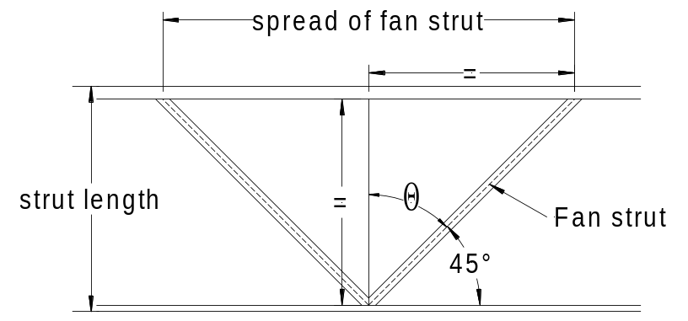

Figure 6

The spread of a vertical fan strut is therefore 0.862 × 2 = 1.724 m
and
The spread of a perpendicular fan strut is therefore 0.918 × 2 = 1.836 m

